TF-PSU MANUAL
High Efficiency Rugged Aviation
DC to DC Power Supply
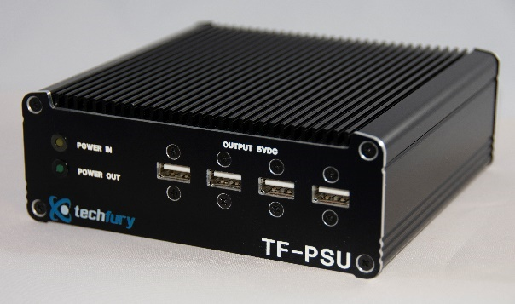

Manufactured by:
TechFury
Engineered Solutions for Harsh Environment Applications

Technical Manual
P/N: TF-PSU
2018

TechFury
200 S. Executive Dr. STE. 201
Brookfield, WI 53005
http://www.TechFury.com
(262) 302-0990

TABLE OF CONTENTS

OVERVIEW
This manual is a complete instructional outline for installation, operation and maintenance for the TF-PSU, a harsh environment aviation grade DC to DC power supply. It contains hardware requirements and specifications for proper usage.

DISCLAIMER
TechFury makes no representations or warranties with respect to the contents of this manual, and specifically disclaims any implied warranties of merchantability or fitness for any particular purpose. TechFury shall under no circumstances be liable for incidental or consequential damages or related expenses resulting from the use of this product, even if it has been notified of the possibility of such damages. TechFury reserves the right to revise this publication from time to time without obligation to notify any person of such revisions. If errors are found, please contact TechFury at the address listed on the title page of this document.

COPYRIGHT (2-15-2018 - TechFury)
No part of this document may be reproduced, transmitted, transcribed, stored in a retrieval system, or translated into any language or computer language, in any form or by any means, electronic, mechanical, magnetic, optical, chemical, manual, or otherwise, without the express written permission of TechFury.

INTRODUCTION
The TF-PSU is a high efficiency aviation grade DC to DC power supply for harsh and unpredictable environments. With an ultra-wide input range of 6-40VDC, the TF-PSU is an ideal power supply for unregulated or battery-operated applications. With two independent power outputs regulated at 5VDC and 12VDC, the TF-PSU can supply power to (7) devices simultaneously. With optional 4 x USB (5VDC) and 4 x Barrel (5.5x2.1mm) or 3 x MIL-SPEC (12VDC) output connectors the TF-PSU offers a array of connectivity options depending on the application.

The TF-PSU uses a state-of-the-art Mosfet based design which provides line and load regulation with efficiencies up to 90%. By using Organic Semiconducting Capacitors, the TF-PSU provide advanced filtering that reduces ripple noises below 20mV, and the low noise design allows for an ideal solution for aircraft, automotive, marine or military applications where EMI and RFI emissions must be minimized.

Features:
- Rugged Aviation Power Supply with multiple outputs (DC to DC)
- Ultrawide Input range of 6VDC to 40VDC
- 4 x 5VDC and 7 x 12VDC outputs
- Tri-stage active transient surge stopper and suppression system
- Reverse Polarity Protection
- Low Noise Design for minimal RFI & EMI
- -40 to +85 degrees C operating temperature
- Compatible with any 12VDC and/or 5VDC device

Specifications:

CONNCTIONS:
Power Input – 6-40VDC  (Rear Panel) | 1 x MIL-SPEC (KPT00A8-3P) (Mating: KPTC6F8-3SDMB)
Power Output – 12VDC  (Rear Panel) | 3 x MIL-SPEC (KPT00A8-3S) (Mating: KPTC6F8-3PDMB) @ 2.5A
 | 4 x 5.5x2.1mm Barrel Connectors (Center Pin Positive) @ 2.5A
Power Output – 5VDC (Front Panel) | 4 x USB at 5VDC (12A)
Physical & Environmental
Operating Temperature | -40° to +85° Celsius (-40° to +185° Fahrenheit)
Storage Temperature | -40° to +85° Celsius (-40° to +185° Fahrenheit)
Weight | 1.75 lbs / 0.79kg / 28oz
Dimensions | 137mm (150mm with connectors) (L) x 140mm (W) x 50mm (H) or  5.4in (5.9in with connectors) (L) x 5.5in (W) x 1.9in (H)
Mounting | 4 x 1/4x20 mounting holes on each side

Front Plate
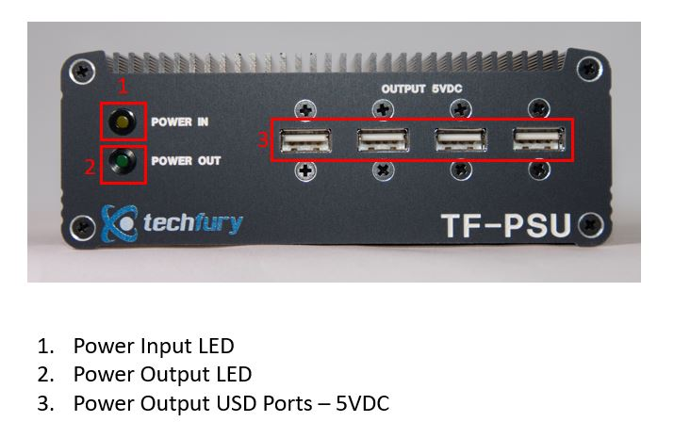
Rear Plate
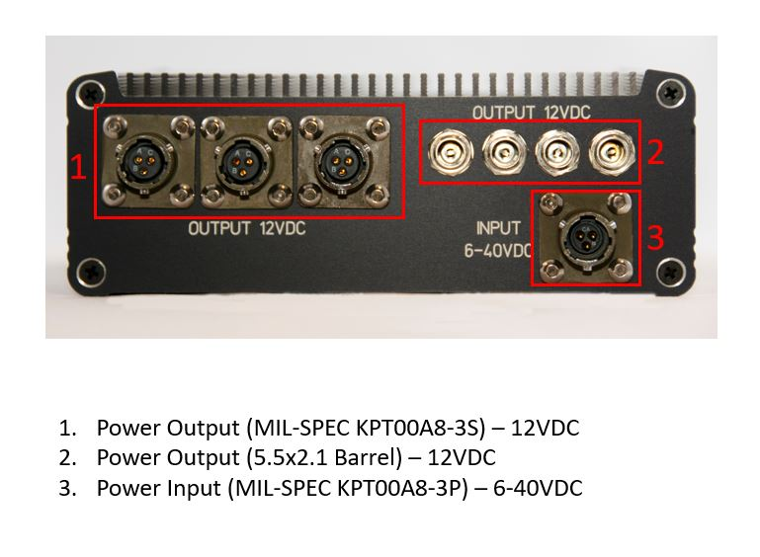

DRAWING WITH DIMENSIONS

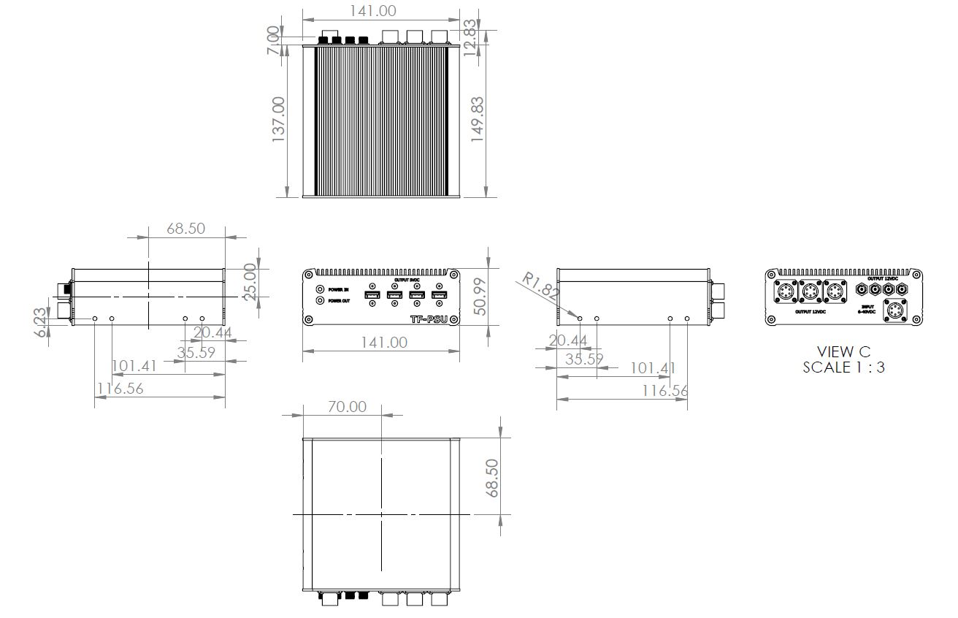

PIN-OUT DIAGRAM:
Power Input (KPT00A8-3P)
PIN A | 6-40 VDC – POSITIVE
PIN B | RETURN – GROUND
PIN C | N/A

Power Output (KPT00A8-3S)
PIN A | 12.0 VDC – POSITIVE
PIN B | RETURN – GROUND
PIN C | N/A

Power Output (5.5x2.1 Barrel)
CENTER  PIN | 12.0 VDC – POSITIVE
OUTER | RETURN – GROUND

OPERATION AND MAINTENANCE

When power is supplied to the TF-PSU using the power input connection, all output connection will become live. For optimal performance, input 28VDC.
This power supply is capable of supplying power to seven connected devices varying in 5VDC and 12VDC. The USB ports on the front panel supply 5VDC from each port. All output connections on the rear panel output at 12VDC. The 5VDC outputs collectively can supply 12 amps and the 12VDC outputs can collectively supply 2.5amps.

